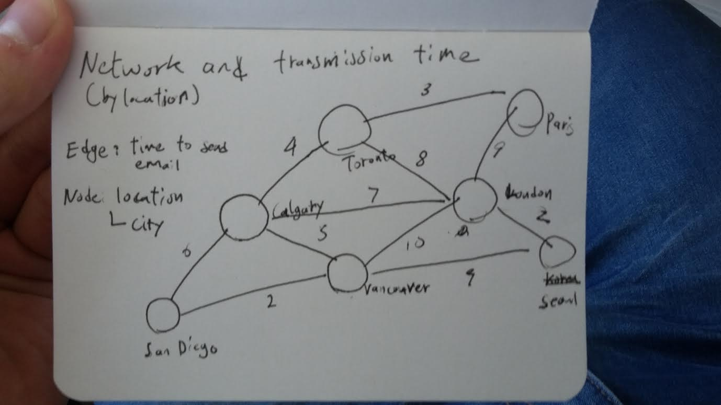

This graph represents internet IP network of various cities.  
  
Each node is a city and each edge represents time in milliseconds for standard 64kb email to reach the city.

For example, Calgary gets to London in 7 milliseconds;

to get to Seoul from Calgary, it has to go through London then Seoul which is total of 9 milliseconds